FLOWCHART PROJECT KASIR KANTIN



UNIVERSITAS MUHAMMADIYAH JAKARTA

FAKULTAS TEKNIK

PRODI INFORMATIKA

KELOMPOK 1

1. Mochammad Gendry Afriansyah -22040700070
2. Mohammad Arief Abean -22040700100
3. Rahmat Fajrial Azim - 22040700028
4. Khoirul Umam - 22040700014
5. Rahmita Zahro -22040700046
6. Meisya Putri Anjani -22040700009

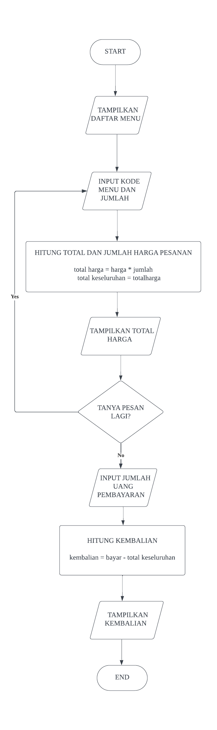

#include <iostream>

using namespace std;

int main (){

int kodemenu, jumlah;

double harga, totalharga = 0, totalKeseluruhan = 0;

char pilihan;

//menampilkan daftar

cout << "======================================" << endl;

cout << " KANTIN TEKNIK INFORMATIKA" << endl;

cout << "======================================"<< endl;

cout << "-------------Daftar Menu--------------"<< endl;

cout << "======================================" << endl;

cout << "No. Nama Menu Harga" << endl;

cout << "======================================"<< endl;

cout << "1. Mie Ayam Pangsit : Rp.15.000"<< endl;

cout << "2. Nasi Goreng : Rp.10.000"<< endl;

cout << "3. Soto Ayam dan nasi : Rp.15.000"<< endl;

cout << "4. Mie Indomie : Rp.7.000"<< endl;

cout << "5. Es Teh : Rp.4.000"<< endl;

cout << "6. Kopi : Rp.4.000"<< endl;

cout << "======================================"<< endl;

//input perhitungan pesanan

do{

//input kode menu

cout << "Masukkan Kode Menu :";

cin >> kodemenu;

//deklarasi kode menu

if (kodemenu >= 1 && kodemenu <= 6){

cout << "Masukkan Jumlah Pesanan :";

cin >> jumlah;

//menghitung total harga

switch (kodemenu){

case 1:

harga = 15000;

break;

case 2:

harga = 10000;

break;

case 3:

harga = 15000;

break;

case 4:

harga = 7000;

break;

case 5:

harga = 4000;

break;

case 6:

harga = 4000;

break;

}

totalharga = harga \* jumlah;

totalKeseluruhan += totalharga;

}else {

cout << "Kode Menu tidak valid." << endl;

}

//menampilkan total harga dan menanyakan apakah ingin memesan lagi

cout << "Total Harga : Rp."<< totalharga << endl;

cout << "Apakah ingin menambah pesanan? (y/n) :";

cin >> pilihan;

}while (pilihan == 'y' || pilihan == 'Y');

// perhitungan pembayaran dan kembalian

double bayar;

cout << "\n======================================" << endl;

cout << "Total Harga Keseluruhan : Rp." << totalKeseluruhan << endl;

cout << "Masukkan Jumlah Uang Pembayaran : Rp.";

cin >> bayar;

double kembalian = bayar - totalKeseluruhan;

if (kembalian >= 0) {

cout << "Kembalian : Rp." << kembalian << endl;

} else {

cout << "Jumlah uang pembayaran kurang." << endl;

}

cout << "======================================" << endl;

return 0;

}